Assignment 2 of Supervised Learning
Name:

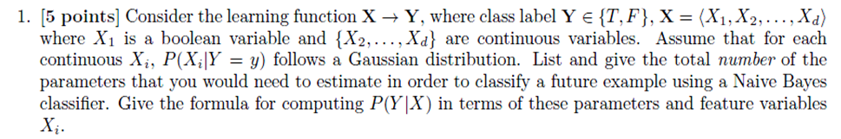

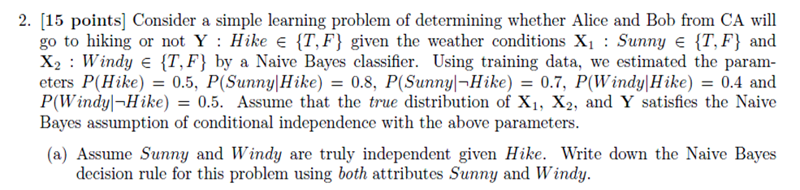
Note: This question is worth 5 points.

(b) What is the joint probability that Alice and Bob go to hiking and the weather is sunny and windy, that is P(Sunny, Windy, Hike)? What is the joint probability that Alice and Bob do not go to hiking and the weather is sunny and windy, that is P(Sunny, Windy, ┐Hiking). What is the probability of prediction error in this case if we use the Naïve Bayes classifier (i.e. the decision rule in (a)) to predict if Alice and Bob go to hike when the weather is sunny and windy?
Note: This question is worth 10 points

Bonus Question (optional): if you answer the question below correctly, you will receive 5 bonus points.
(c) Given the decision rule in (a), what is the expected error rate (i.e. loss) of the Naïve Bayes classifier? Hint: you may generate the joint probabilities of all possible combinations of whether conditions and Hike and use the decision rule to make prediction as in (b), and then sum up all the probabilities of error.

